**WEB TECHNOLOGY**

**TITLE-BUS TICKET**

**BOOKING SYSTEM**

**MEMBERS OF THE TEAM**

* **L.SUKIRTHA(2018506128)**
* **M.MEENA(2018506061)**
* **G.POORNASHREE(2018506076)**

**SCOPE OF THE PROJECT:**

Bus ticket booking system is a program used to book the tickets in the buses. It also has the facility to see the list of buses available from source to destination. And also displays the payment information.

**OBJECTIVES:**

* Bus app to book tickets in buses.
* It is efficient and user friendly.
* Facilitates the passenger and provides the passenger with details below.

1. Details of the buses available.
2. Book tickets.
3. Cancel tickets.
4. Payment details.

**Front end:**

* **HTML**

**BACK END:**

* **JAVA SERVLET**
* **SQL**

**SERVER:** TOMACAT SERVER.

**IDE:**  ECLIPSE

**Source files:**

The source files are:

* **Welcome.html**
* **Login.html**
* **Bus.html**
* **Busserv.java**
* **Reg.java**
* **Final.html**
* **Logout.html**

**Welcome.html :**

* This file displays that whether the passenger want to register
* Click register button. It goes to the registration page.
* If the passenger wants to login
* Click login. It redirects to login page
* If the passenger clicks logout then it redirects to logout page.

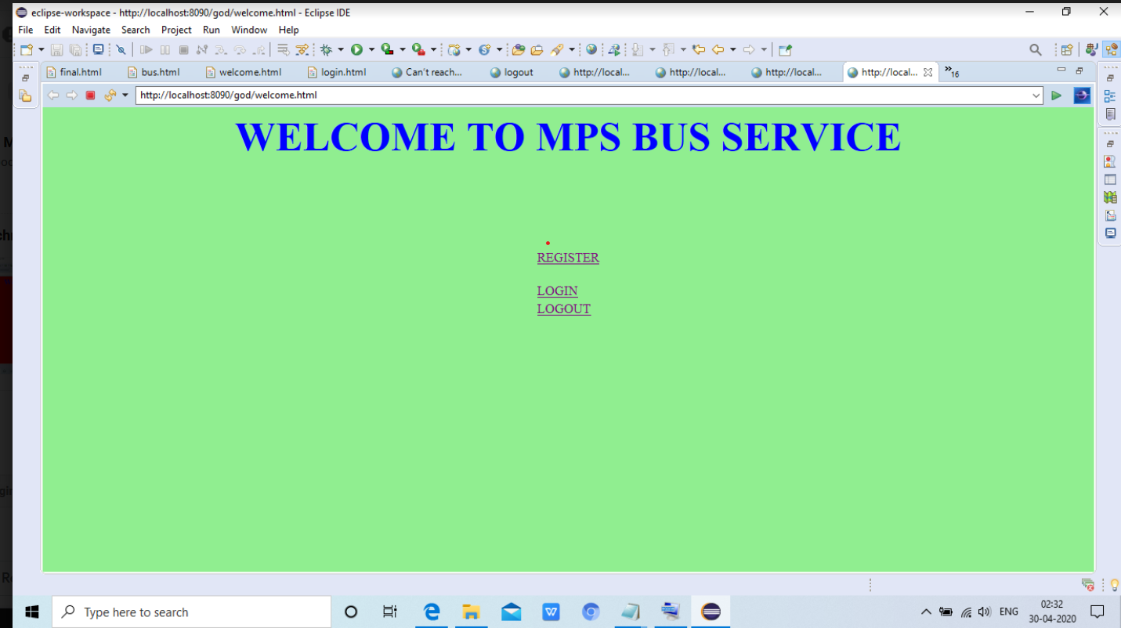

**Registration page:**

* This page welcomes you to the registration.
* You have create your own account with an email id and password.

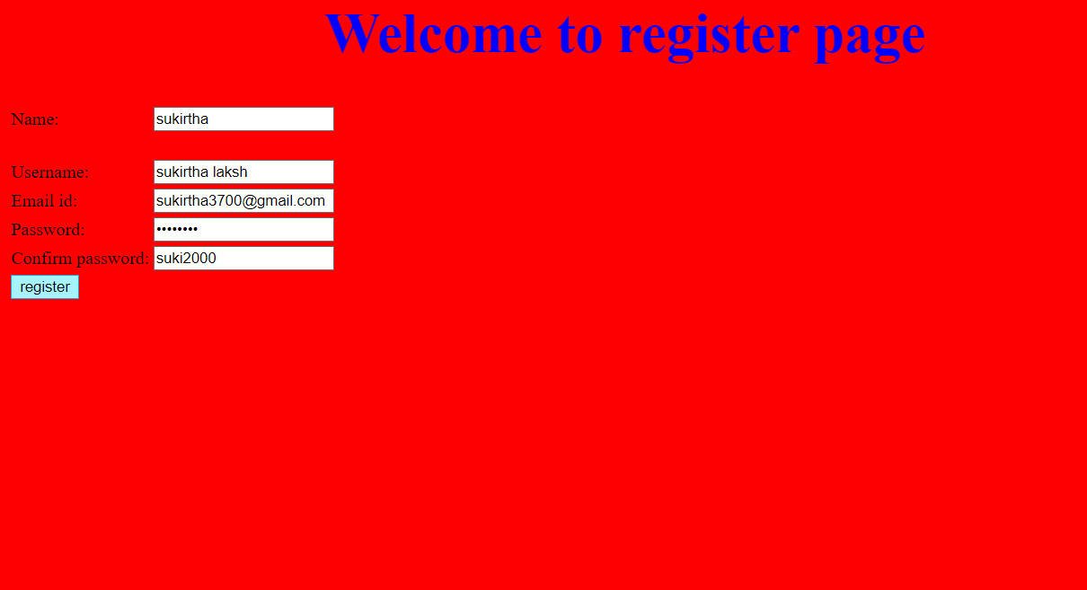

**Login page:**

It allows the user to enter the username and password

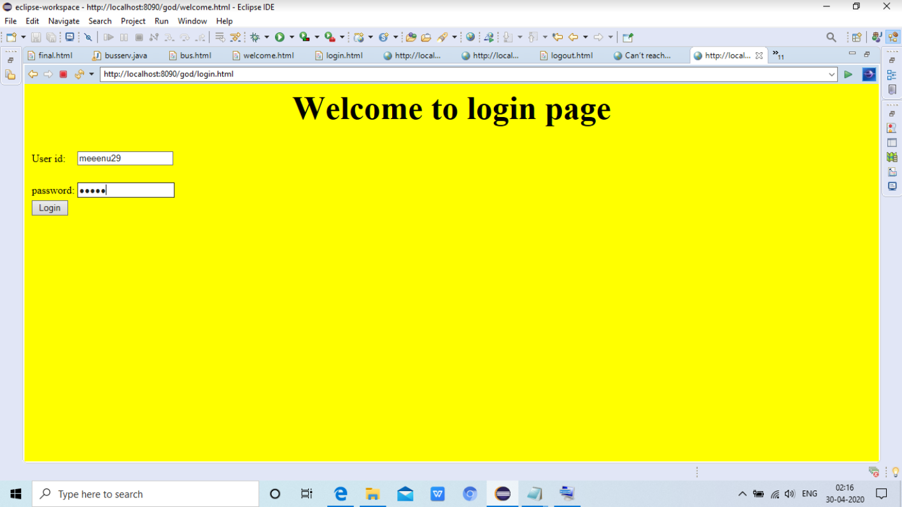

**Bus.html:**

* This file shows the lists of buses available.
* And shows the arrival time and departure time of the bus.
* It shows the travelling cost for each bus.
* And also shows the total no seats available.
* If the customer want to book - click the book button it redirects to final.html
* If the customer want to cancel -click the cancel button and amount is refundable.

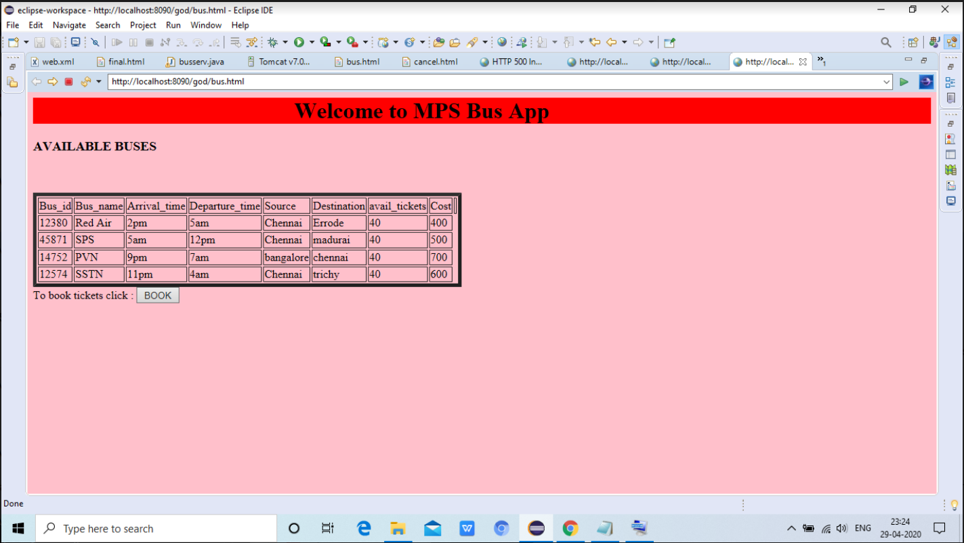

**Busserv.java:**

* This file has the details about the passengers and checks that the provided valid informations.
* And also checks the seatno they registered is available are not.
* If available then it calculates the cost.
* Otherwise gives a error message.
* If the passenger want to cancel a ticket then performs refund operation.
* The passenger has to click the button within 30 seconds otherwise it redirects to welcome page.

**Reg.java:**

* 1. This file allows the passenger to register the tickets and cancel tickets.
  2. This app allows the user to create their account and allows the passenger to login next time.
  3. And also checks the username and password.

**Final.html:**

* In this file passenger has to fill his\her details as given below.
* We assure that the passenger that their information are safe and predicted from malfunctions.
* All the given boxes must be filled.
* Payment options are given below.

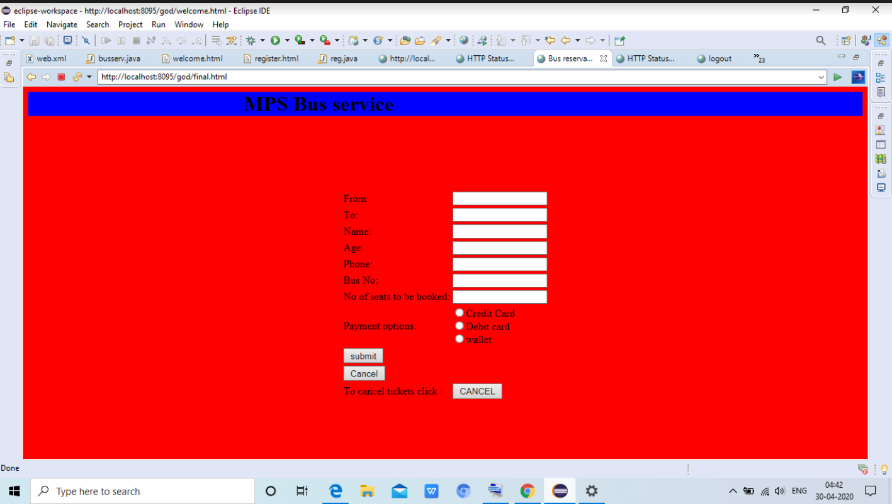

**SQL:**

**This file has the database of the passenger and maintains the history of the passenger.**

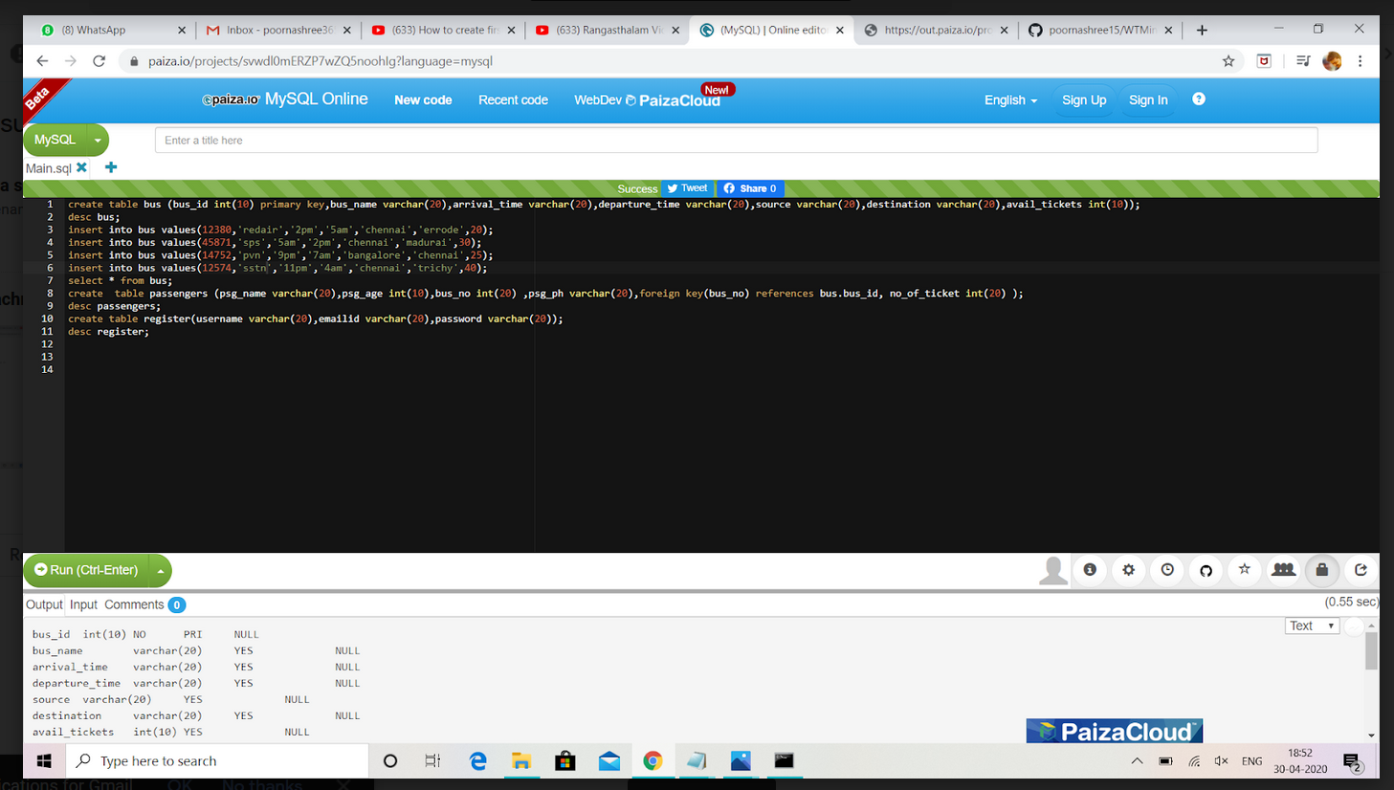

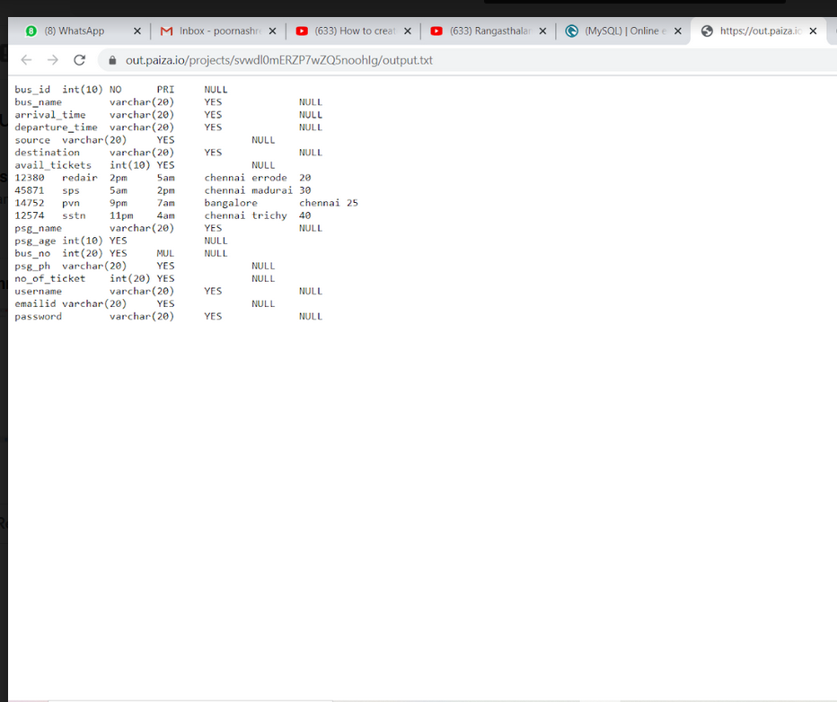

**LOGOUT PAGE:**

* This page displays the log out message.

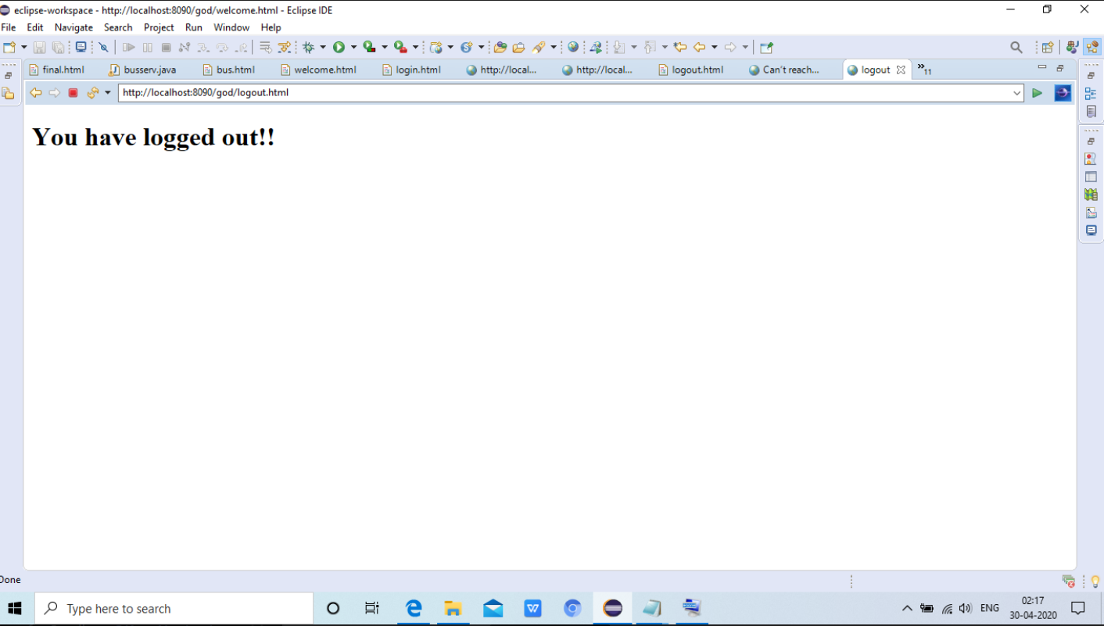

**SAMPLE OUTPUTS:**

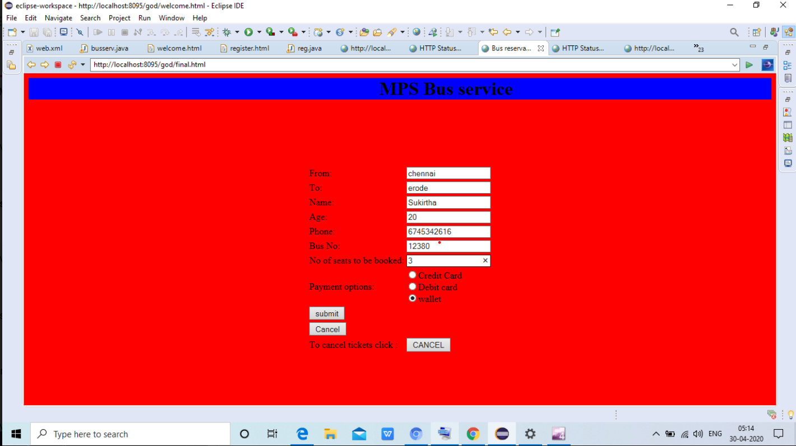

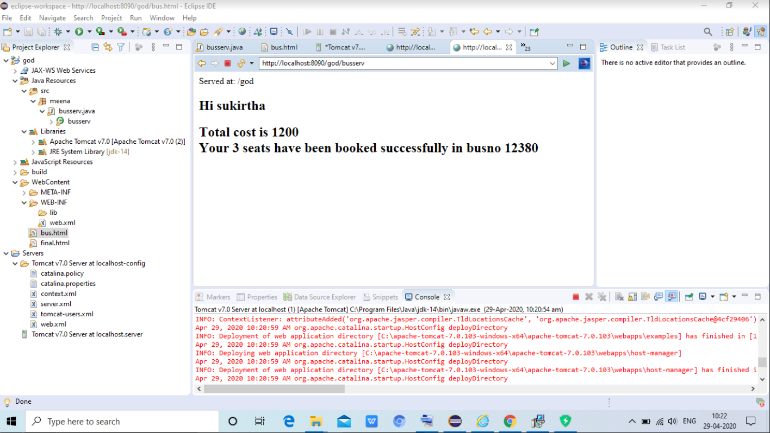

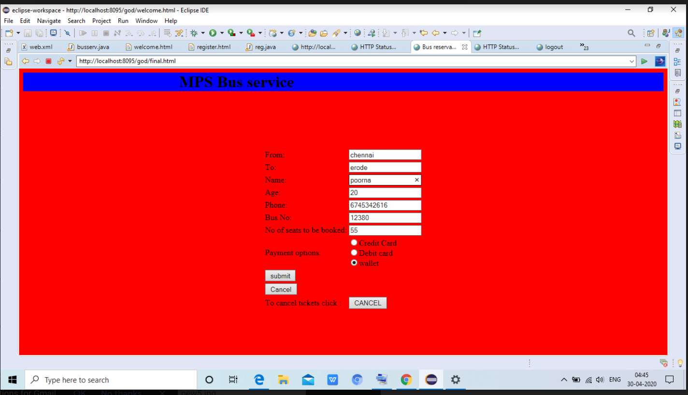

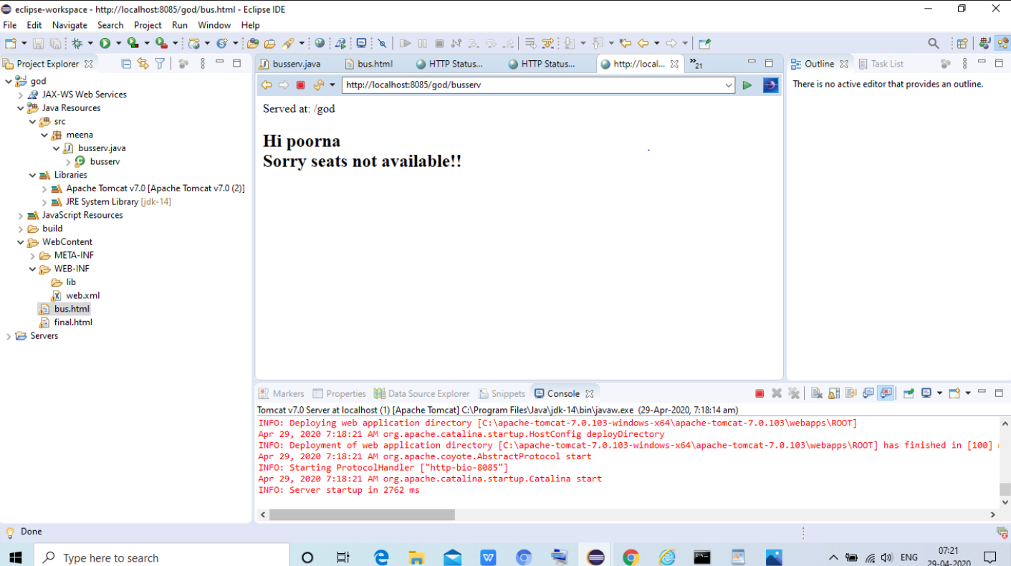

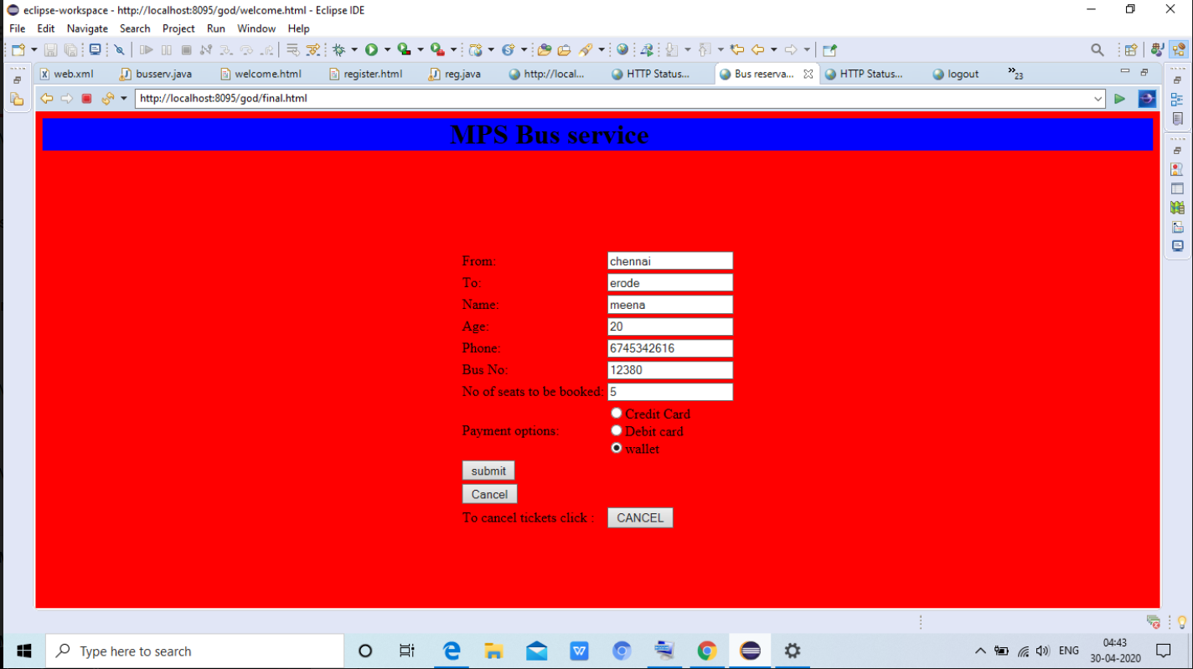

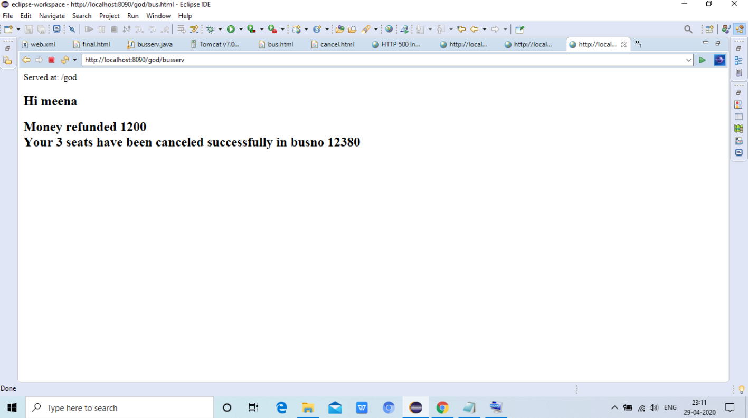

**COST ESTIMATION:**

**Module used: ORGANIC:**

**LOC=512 KLOC=0.512**

effort(E)=2.4(KLOC^1.05)person-month=2.4(0.512^1.05)=1.18835~1 person-month

time(T)=2.5(E^0.38)

=2.5(1^0.38)=2.5~2 months

average person=E/T=1/2~=1

productivity=KLOC/E=0.512/1=512LOC/person-month

suppose the project will take rs.4000/person-month

total cost=1*4000=4000

**Conclusion:**

*This project will be in user friendly manner.Thus the project allows the user to book and cancel tickets and he /she can create their own account in our bus app.*